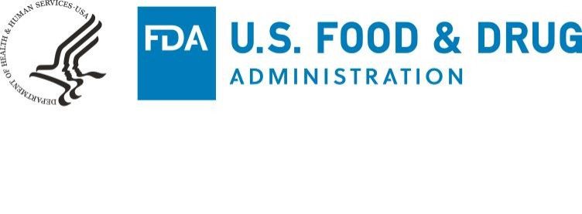

July 21, 2020

To Manufacturers and Other Stakeholders:

This letter is to notify you of the revocation of the Emergency Use Authorization (EUA) issued April 28, 2020, for emergency use of certain in vitro diagnostic SARS-CoV-2 Antibody Tests1 intended for use as an aid in identifying individuals with an adaptive immune response to SARS-CoV-2, indicating recent or prior infection, by detecting antibodies (IgG, or IgG and IgM, or total) to SARS-CoV-2 in human plasma and/or serum.

The authorization of a device for emergency use under section 564 of the Federal Food, Drug, and Cosmetic Act (the Act) (21 U.S.C. 360bbb-3) may, pursuant to section 564(g)(2) of the Act, be revised or revoked when the criteria under section 564(b)(1) of the Act no longer exist, the criteria under section 564(c) of the Act for issuance of such authorization are no longer met, or other circumstances make such revision or revocation appropriate to protect the public health or safety.

FDA has determined that circumstances make revocation of this EUA appropriate to protect the public health or safety. Any SARS-CoV-2 Antibody Tests added to the list of authorized devices in Appendix Aof the April 28, 2020, letter of authorization would have been authorized for: (1) human plasma and/or serum samples only, (2) use only at laboratories certified under the Clinical Laboratory Improvement Amendments of 1988 (CLIA) to perform moderate or high complexity tests, and (3) the detection of IgG only, IgG and IgM, or total antibodies (i.e., not for the detection and differentiation of IgA from other immunoglobulins). To date, no device has been listed in Appendix A.

Based on information and experience since issuance of the umbrella EUA, FDA has determined that circumstances support revocation of the umbrella EUA so that FDA may issue individual EUAs. Individual EUAs will allow for broader indications and scopes of authorization, individualized conditions of authorization to address any issue unique to a specific test, and more streamlined EUA amendments, such as additional uses that would not fall under this umbrella EUA. Accordingly, FDA has decided to revoke this EUA. Instead, FDA will issue individual EUAs for SARS-CoV-2 Antibody Tests that meet the requisite EUA statutory criteria.

FDA has determined that circumstances make revocation of this EUA appropriate to protect the public health or safety for purposes of section 564(g)(2)(C) of the Act.

1 The SARS-CoV-2 Antibody Tests eligible for authorization under this EUA were Lateral Flow or Enzyme-linked immunosorbent assay (ELISA) tests that had been evaluated in an independent validation study performed at the National Institutes of Health’s (NIH) National Cancer Institute (NCI), or by another government agency designated by FDA.
Page 2 – SARS-CoV-2 Antibody Tests

Accordingly, pursuant to section 564(g)(2) of the Act, FDA revokes the EUA issued on April 28, 2020.

Notice of this revocation will be published in the Federal Register, pursuant to section 564(h)(1) of the Act.

Sincerely,

___________________________ RADM Denise M. Hinton
Chief Scientist
Food and Drug Administration

